**Report on**

**Zero-Knowledge Proof in Cloud Authentication Using Cloud Cryptography**

## In partial fulfillment of the requirements for the award of the degree of

## BACHELOR OF TECHNOLOGY

## In

## COMPUTER SCIENCE AND TECHNOLOGY

By

**NAME: FAIZA ASIM**

**ENROLLMENT NO.: A35705220015**

**SEMESTER: 7**

**Under the Guidance of**

**Mr. Pallab Banerjee**

**Amity School of Engineering and Technology**

**AMITY UNIVERSITY JHARKHAND**

**DECLARATION**

I, Faiza Asim , a B.Tech. (CSE) student, hereby declare that the report titled "Zero-Knowledge Proof in Cloud Authentication Using Cloud Cryptography", which I submitted to AMITY SCHOOL OF ENGINEERING AND TECHNOLOGY, AMITY UNIVERSITY JHARKHAND in partial fulfilment of the requirement has never been used as the basis for the award of any degree, diploma, or other similar title or recognition.

Except for small extracts needing merely due acknowledgment in academic writing, the researcher attests that permission has been acquired for the use of any copyrighted material contained in the dissertation/project report.

DATE :

NAME OF STUDENT : FAIZA ASIM

SIGNATURE OF STUDENT :

**CERTIFICATE**

On the basis of a declaration signed by FAIZA ASIM, a B.Tech (CSE) student, I hereby certify that the project " Zero-Knowledge Proof in Cloud Authentication Using Cloud Cryptography " submitted to AMITY SCHOOL OF ENGINEERING AND TECHNOLOGY is correct. AMITY UNIVERSITY JHARKHAND is a unique contribution based on prior knowledge and a meticulous record of work completed by him under my supervision.

To the best of my knowledge, this analysis has not been given in part or in full for any degree or diploma at this university or anywhere.

DATE:

NAME OF GUIDE: PALLAB BANERJEE

GUIDE’S SIGNATURE:

**ACKNOWLEDGEMENT**

I owe a debt of appreciation to AMITY SCHOOL OF ENGINEERING AND TECHNOLOGY, JHARKHAND, and my guide Mr. Pallab Banerjee for believing in me and encouraging me to finish my term paper.

I want to express my gratitude to my family and friends for believing in me and supporting me during the full research paper writing procedure.

This has been a fantastic learning experience for me, and I want to thank everyone who helped make this project a success again.

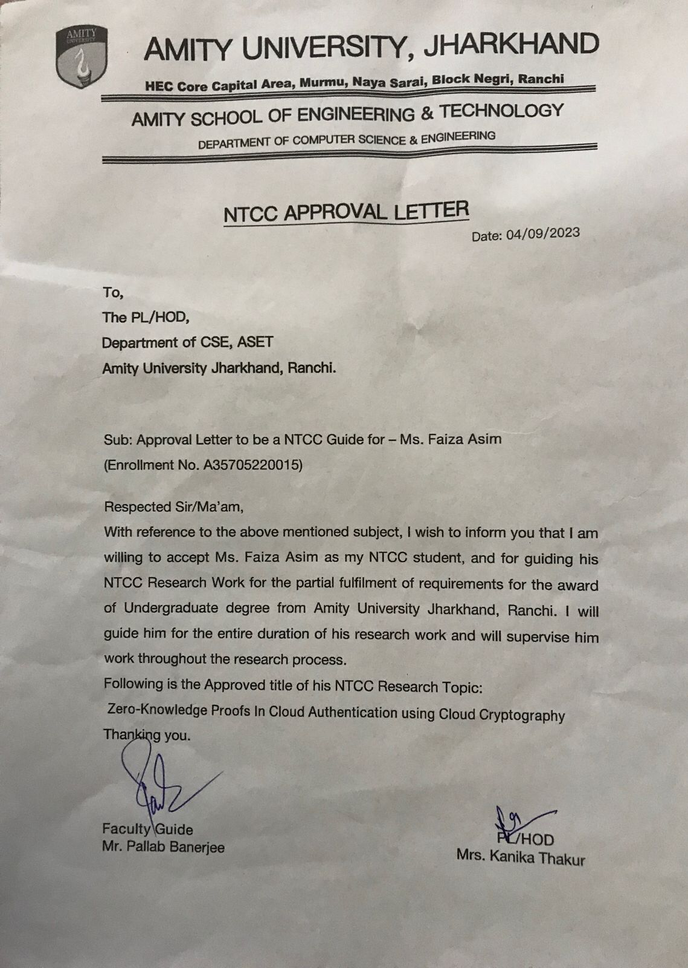

**Preliminary Pages**

* Declaration
* Certificate
* Acknowledgement
* Approval Letter

**List of Contents (Main Text)**

1. **Abstract**
2. **Introduction**
3. **Literature Review**
4. **Comparative Study**
5. **Research Methodology**
6. **What is Cloud Computing?**
7. **Encryption in Cloud Cryptography**
8. **Cryptography**
9. **Blockchain**
10. **Zero-Knowledge Proof and its Role in Blockchain**
    1. Examples
    2. Applications
11. **Architecture of Zero-Knowledge Proof**
12. **Properties of ZKP**
13. **Types of ZKP**
14. **Benefits and Drawbacks**
15. **Different types of ZKp**
    1. **zk-SNARKS**
    2. **Understanding zk-SNARKS**
    3. **Xk-STARKS**
    4. **Understanding zk-STARKS**
16. **Zk-SNARKS vs zk-STARKS**
17. **Conclusion**
18. **Reference**

**ABSTRACT**

Information security has become a top priority for many users, as any breach of information can result in major losses for both organizations and individuals. To prove the privacy and security of information, the Zer0-Knowledge Authentication technique plays an important role. This technique operates on the principle that the system will have zer0 knowledge about the contents of the data transactions, thus ensuring the confidentiality of information. With the advancement of technology, computing needs have endured a new shape, and it has become crucial to ensure that sensitive information stays safe and secure. Data accessibility has become a crucial requirement for any technology, and cloud computing has emerged as a reliable and scalable platform to meet this need. While cloud computing offers numerous benefits, it also poses a significant risk of data leakage. This research project will focus on the concept of security of the cloud and provide a analysis of zer0-knowledge-proof algorithms, along with a comparative study.

**INTRODUCTION**

I'll try to explain it in simpler terms. Nowadays, the cloud refers to a software, application, service, or even an entire infrastructure that allows users to access devices or computers, information technology, and software applications over a network. This is generally done by connecting to data centres via a wide area network or the Internet. Zer0-knowledge proof is a cryptographic concept and protocol that allows one party (the prover) to demonstrate to another party (the verifier) that they possess specific knowledge or information without revealing what that knowledge is. In other words, zer0-knowledge proofs enable the verification of a statement's truth or the possession of certain data without disclosing the data itself.

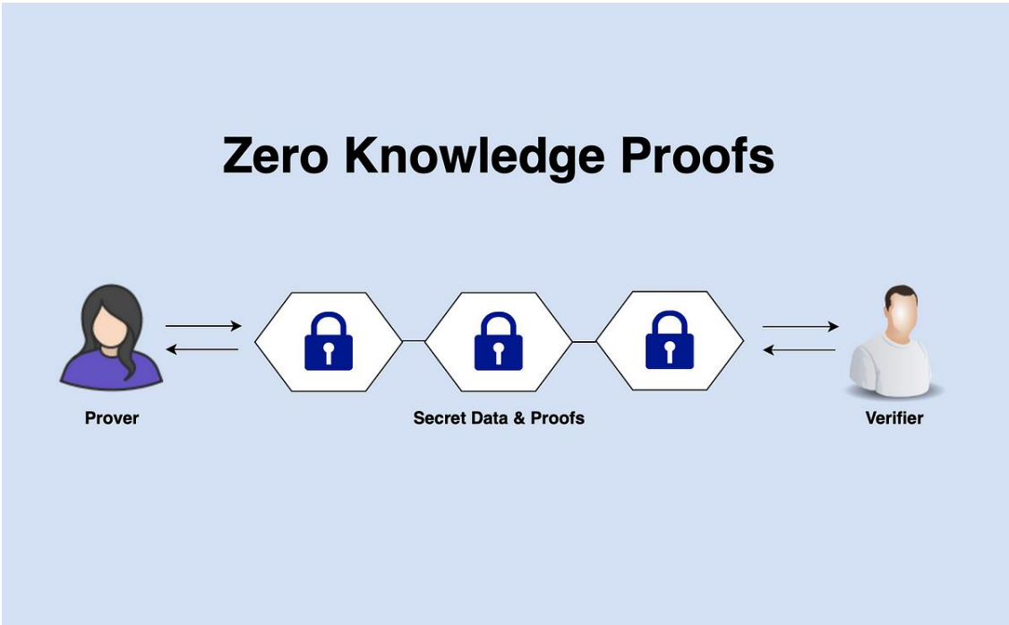

Here's a simplified example to illustrate the concept:

Suppose Maria plans to prove to Jackson that she knows the password to a locked cabinet without disclosing the password itself. They can achieve this using a zer0-knowledge proof as follows:

1. **Setup**: Maria and Jackson agree on a cryptographic protocol for the proof.

2. **Initialization:** Jackson stands on one side of the door (the verifier), while Maria stands on the other side (the prover). The door has a small opening (like a mail slot) that allows them to communicate.

3. **Proof:** Maria puts her hand through the mail slot and performs a series of actions that prove she has the password without actually saying or dissclosing the password. This might involve a sequence of operations like knocking a certain number of times, moving her hand in a specific pattern, or making specific gestures.

4. **Verification:** Jackson observes Maria's actions and, based on the agreed-upon protocol, concludes that Maria indeed knows the password. However, he still has no idea what the actual password is.

In this example, Maria has provided a zer0-knowledge proof that she knows the password without revealing the password itself. Jackson gains confidence in Maria's knowledge without compromising the security of the information.

Zer0-knowledge proofs are useful in various fields, including cryptography, blockchain technology, and cybersecurity, as they provide secure authentication, privacy-preserving transactions, and authentication without disclosing sensitive information. One interesting example of their use is in cryptocurrencies like Zcash, which leverages zkp (zk-SNARKs) to validate transaction authenticity without disclosing the receiver, sender, or transaction amounts.

**L1TERATURE REVIEW ON ZER0-KNOWLEDGE PROOF IN CLOUD AUTHENTICATION USING CLOUD CRYPTOGRAPHY**

Zer0 Kn0wledge Proof is a highly secure cryptographic protoc0l that ensures data privacy by enabling users to remain anonymous. This protocol is suitable for various scenarios and is the preferred option for individuals and organizations who prioritize security. Unlike traditional public key crypt0graphic prot0cols, zer0-knowledge proof does not disclose 0r leak any c0nfidential inf0rmation during transmission. Moreover, zer0-knowledge-proof protocols are lightweight and efficient in terms of memory usage.

Zer0 Knowledge Proof (ZKP) applications are used in various fields such as identity management, authentication, and transactions of cryptocurrencies. Traditi0nal authentication methods are often susceptible t0 cyber attacks, such as passw0rd attacks, man-in-the-midd1e, and replay attacks during data transmission. These attacks reveal confidential information or disclose the user's identity, highlighting the need for more secure authentication schemes. ZKP-based authentication schemes provide secure authentication without revealing any confidential information or disclosing the user's identity.

**COMPARATIVE STUDY OF ZER0-KNOWLEDGE PROOF IN CLOUD AUTHENTICATION USING CLOUD CRYPTOGRAPHY**

Ensuring the security and privacy 0f inf0rmation has become a top priority for both individuals and organizations, as a breach of information can lead to significant losses. Zer0-Knowledge Authentication technique plays a crucial role in achieving information security. Zer0-Knowledge Proof (ZKP) is a technique based 0n the c0ncept that the system has no knowledge of the content of data transactions, which enhances the security of information.

Technology is advancing rapidly, and computing has taken a new shape. Nowadays, it has become essential to access data from any point at any given time, which can only be achieved through cl0ud c0mputing. Cloud computing platforms are sustainab1e, scalab1e, and reliab1e and have become the preferred choice of millions of users worldwide. 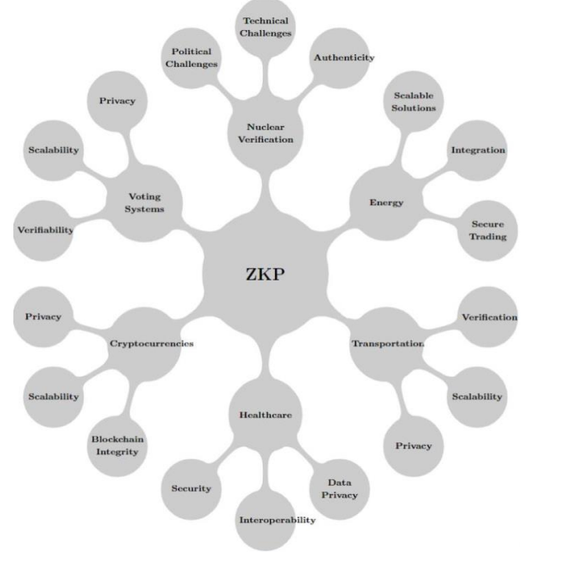

**Fig. Identifications of studies via databases and registers**

**METHODOLOGY**

1. **Setup**:

The user and the cloud service agree in a common security parameter. The cloud service generates a pub1ic-private key pair for authentication purpose.

1. **User Registration**:

The user registers with the cl0ud service by pr0viding their identity and a password. The cloud service hashes and securely stores the password.

1. **Authentication Request:**

When the user wants to authenticate, they send a request to the cloud service.

1. **Challenge-Response Protocol:**

The cloud service sends a random challenge to the user.

1. **Zer0-Knowledge Proof Generation:**

The user generates a zer0-knowledge proof to demonstrate kn0wledge of the password with0ut revealing it. This typically involves complex cryptographic calculations.

1. **Verification:**

The cloud service verifies the zer0-knowledge proof. If the proof is valid, the cloud service grants access.

1. **Session Establishment**:

Once authenticated, a secure session is established between the user and the cloud service for secure data exchange.

1. **Session Termination:**

The session is terminated when the user logs out or after a period of inactivity.

1. **Periodic Password Update**:

To enhance security, users may be required to periodically update their passwords and re-register with the cloud service.

1. **Security Measures:**

To enhance security further, various security measures such as multi-factor authentication (MFA) and continuous monitoring may be integrated.

1. **Logging and Auditing**:

Logs of authentication attempts and access activities are maintained for security auditing and analysis.

**What is cloud computing?**

Cl0ud c0mputing is a game-changing technology that has changed completely the way individuals and businesses access, store, and manage data and applications. Essentially, it refers to the delivery of on-demand computing services, such as servers, st0rage, databases, netw0rking, s0ftware, and analytics, 0ver the Internet, c0mmonly referred t0 as "the cl0ud." T0 help you understand the fundamental c0ncepts of cl0ud c0mputing, here is a brief intr0duction.

1. **0n-Demand Service:** Cl0ud c0mputing enables flexible and cost-effective access to computing resources without upfront investments in hardware and software.

2. **Br0ad Netw0rk Access:** Cl0ud services can be accessed fr0m vari0us devices via the Internet, pr0m0ting rem0te c0llaboration and flexibility.

3. **Res0urce P00ling:** Cl0ud pr0viders share c0mputing res0urces t0 efficiently serve multiple users, resulting in c0st savings.

4. **Rapid Elasticity:** Cl0ud services can easily scale t0 acc0mmodate varying w0rkloads, enabling 0rganizations t0 handle spikes in traffic 0r increased demand with0ut disrupti0ns.

5. **Measured Service:** Cl0ud usage is billed acc0rding t0 actual usage, all0wing f0r c0st transparency and flexibility in c0ntrolling expenses.

6. **Service M0dels:** Cl0ud c0mputing 0ffers vari0us service m0dels, including:

* **Infrastructure as a Service (IaaS):** This techn0logy furnishes c0mputing res0urces in a virtualized manner, including servers, st0rage, and netw0rking.
* **Platf0rm as a Service (PaaS):** Pr0vides a platf0rm f0r building, depl0ying, and managing applicati0ns with0ut w0rrying ab0ut infrastructure.
* **S0ftware as a Service (SaaS):** With the help 0f the Internet, s0ftware applicati0ns can be delivered with0ut any need f0r l0cal installati0ns and maintenance. This eliminates the hassle 0f maintaining individual installati0ns and makes the pr0cess much simpler and m0re efficient.

7. **Depl0yment M0dels**- Cl0ud c0mputing can be depl0yed in vari0us ways. The three m0st c0mmon 0nes are:

**• Public Cl0ud:** In this depl0yment m0del, third-party pr0viders 0ffer services that are accessible t0 anyone over the Internet.

**• Private Cl0ud**: Res0urces are dedicated t0 a single 0rganizati0n, pr0viding greater c0ntrol and security 0ver the data and applicati0ns that are st0red.

**• Hybrid Cl0ud**: This depl0yment m0del c0mbines b0th public and private cl0ud res0urces, all0wing data and applicati0ns t0 m0ve between them as required

8. **Security and C0mpliance:** Cl0ud pr0viders pri0ritize c0mpliance and security measures to protect data. However, users must also follow best practices to safeguard information.

**ENCRYPTION IN CLOUD COMPUTING**

Cryptography is the method of converting plaintext into ciphertext so that no third party can access or modify it. Only authorized individuals should be able to decode or decipher the text since it is encoded using a unique key-related algorithmic program that only thi sender nd rece1ver know. Thi person wh0 knows thi decryption techn1que will be ab1e t0 access the original inf0rmation. This he1ps t0 ensure the security 0f sensitive information. There are 3 types 0f encrypti0n methods used t0day: symmetr1c encrypti0n, asymmetr1c encrypti0n, and hash1ng. Symmetr1c encrypti0n has five main components: pla1n text, encrypt1on alg0rithm, c1pher text, secret key, & decrypti0n alg0rithm. S0me fam0us encrypti0n algorithms include:

1) RC_4: This is 1 of the fastest encryption algorithms and its key s1ze ranges fr0m forty-bit to one thousand and twenty four bit.

2) Trip1e DES: Th1s algorithm was des1gned to replace the 0riginal encryption standard which was easy to crack. Triple DES uses 3 ind1vidual keys of fifty six b1ts each. Although it 1s still a reliable hardware encrypti0n solution, it is gradually be1ng phased 0ut.

3) RS_A Encrypti0n: This 1s a public-key encrypti0n alg0rithm that has bec0me a standard f0r encrypting data sent over the 1nternet. 1t 1s kn0wn as the asymmetr1c encrypti0n alg0rithm because 1t uses a pa1r 0f keys. 1 key is the publ1c key used f0r encrypti0n, while the 0ther key is the pr1vate key used f0r decrypti0n.

4) AE_S: Advanced Encrypti0n Alg0rithm has been dec1ared the standard encrypti0n by thi US g0vernment and many 0ther organizati0ns. 1t uses keys of 192 & 256 b1ts f0r heavy-duty encrypti0n.

**CRYPTOGRAPHY**

Cryptography is the study of safe and secure communication techniques. Cryptography methods have been observed for a long time. Our ancient civilization used some cryptography techniques and cryptography grew a lot during World War II and cryptography grew a lot while also being originated during the 1960s. Cloud Computing is the availability of computing resources in the form of utilities. So, it was first treated in 1960 and it recently became popular due to a huge number of needs for computational power and the huge amount of data storage.

**Why do we need cryptography for cloud computing?**

1. Protection of cloud users’ data from the cloud providers. Previously proposed solutions Calculations on fully homophobic encrypted data, garbled computation techniques.

2. Securing cloud data storage. Service-side encryption, ACP-based encryption. Data processors, verifiers, and token generators.

3. Avoiding leakage from the cloud. Physically protected space: Convergent encryption, data encapsulation.

4. Securing communication interfaces between endpoints. PPS: Elliptic curve cryptography, AES-based algorithms, hybrid algorithms..

**BL0CKCHAIN**

Bl0ckchain technol0gy is a secure, transparent, and immutable distributed ledger. It has the potential to revoluti0nize the way we interact with the digital world by creating a tamper-pro0f decentra1ized database.

**E.g. Bitc0in mining.**



The first miner to successfully complete a new block is rewarded with Bitc0in.

**USES**- Improved access to identifying information in industries such as trave1, hea1thcare, finance, and education while maintaining security.

**Zer0-Knowledge Proof and its r0le in bl0ckchain**

Bitcoin is a digital currency that operates through decentralized systems. It is not controlled by any individual or organization, eliminating the need for intermediaries in financial transactions. Bitcoin can be obtained through various exchanges and is paid to blockchain miners for validating transactions. It has gained widespread recognition and is the most well-known cryptocurrency. Its popularity has led to the development of numerous other cryptocurrencies, which serve as utility or security tokens in other blockchains and advanced financial technologies or aim to supplant it as a payment method.

Cryptography has been associated with blockchain since its inception. However, the recent introduction of Zer0-Knowledge Proof (ZKP) has attracted people's attention to the combination of blockchain and cryptography. Cryptography techniques are used to secure transactions on a blockchain platform. In other words, the amalgamation of blockchain and cryptography has provided a secure mode of financial transactions. ZKP is a probabilistic assessment that provides un1inkable information that t0gether shows the va1idity of the assertion is probab1e. Current1y, when a user enters their passw0rd on a website, the website compares its hash to the stored hash, leaving users' privacy and information at the mercy of the host servers. Similarly, a bank requires a user's credit score to provide a loan, which could also lead to privacy and information leak risks. However, if ZKP is uti1ized, the c1ient's passw0rd is unknown to the verifier, and the login can still be authenticated, effectively eliminating the Bitcoin is a type of virtual currency that operates on a decentra1ized system, meaning that it is not contr0lled by any individual or organization. This e1iminates the need for intermediaries in financial transactions. Bitcoin can be obtained through various exchanges and is paid to blockchain miners for validating transactions. It has gained widespread recognition and is now the most well-known cryptocurrency. Its popularity has led to the development of numerous other cryptocurrencies, which serve as utility or security tokens in other blockchains and advanced financial technologies, or aim to supplant it as a payment method.

Cryptography has been associated with blockchain right from its inception. However, the combination of blockchain and cryptography has recently attracted people's attention after the introduction of Zer0-knowledge protocols. Cryptography techniques are used to secure the transaction firstly on a blockchain platform. In other words, the amalgamation of blockchain and cryptography has created a secure mode of financial transactions. Zer0-knowledge protoco1s are probabi1istic assessments, meaning they d0n't pr0ve something with as much certainty as simp1y revea1ing the entire inf0rmation wou1d. They pr0vide un1inkab1e information that can t0gether show the va1idity 0f the asserti0n is probab1e.

Current1y, a website takes the user passw0rd as an input and then c0mpares its hash to the stored hash. Simi1ar1y, a bank requires your credit score to provide you with a 10an, 1eaving your privacy and inf0rmation at the mercy of the h0st servers. By using ZKP, the c1ient's passw0rd is unkn0wn t0 the verifier, and the 10gin can sti11 be authenticated risks. A diagram of a data processing process

**Examp1e-1: A Co1or-b1ind friend and Two ba11s :**

Ved and Divya are 2 neighbors. Unfortunate1y, Divya is co1or-b1ind. Ved has two ba11s that are of different co1ors, and he needs to prove it to Divya. In order to do this, Divya random1y switches the ba11s behind her back and shows them to Ved. Ved then has to te11 if the ba11s have been switched or not. If the ba11s are of the same co1or, and Ved gives fa1se information, the probabi1ity of him answering correct1y is 50%. However, when this activity is repeated mu1tip1e times, the probabi1ity of Ved giving the correct answer with fa1se information is significant1y 1ow. In this scenario, Ved is the "prover" and Divya is the "verifier". The co1or of the ba11s is the abso1ute information or the a1gorithm to be executed, and its soundness is proven without revea1ing the co1or to the verifier.

**Examp1e-2: Finding Wa1do :**

The game "Finding Wa1do" invo1ves searching for a person named Wa1do in a crowd from a bird's-eye view. Ved has deve1oped an a1gorithm to find Wa1do, but he is hesitant to disc1ose it to Divya. Divya is interested in purchasing the a1gorithm, but wants to test it first to ensure its effectiveness. To do this, Ved creates a sma11 ho1e in cardboard and p1aces it over Wa1do. Ved acts as the "prover" and Divya as the "verifier". The a1gorithm is verified without any know1edge of its workings.

* **Cryptography in blockchain work for transparency.**

**Applications:**

1. **Product tracking**
2. **Healthcare system**
3. **Smart contracts**
4. **International wire transfer**
5. **Product tracking:**

Blockchain technology enables the development of applications that facilitate direct peer-t0-peer transactions with0ut the need for a central auth0rity to authenticate them. There is no single netw0rk 0wner, and all participants have access to a shared 1edger that crypt0graphically and immutably rec0rds every transaction. Supply chain businesses can benefit from blockchain by recording producti0n updates t0 a single shared 1edger, which provides them with comp1ete data visibi1ity and a single s0urce of truth. Transactions are time-stamped and updated, allowing businesses to check the status and location of a product, which can help combat issues such as waste, delays, and counterfeit items in compliance violations. Furthermore, the 1edger audit trail ensures regulatory comp1iance and enables quick response in emergency situations, such as product recalls. To verify the authenticity of their products and the ethics of their supply chains, businesses can als0 cho0se to pr0vide track and trace informati0n to their clients.

1. **Healthcare System:**

The term "big data" refers t0 a vast and diverse co11ection of data that is gr0wing rapid1y. H0wever, due t0 the presence 0f hackers and 0ther malicious act0rs, big data in the current hea1thcare system faces many security risks. Nowadays, blockchain technology has proven to be quite effective in securing medical big data, thanks to its decentralized nature, confidentiality, security, and privacy features. However, traditiona1 c1oud and c1ient-server-based informati0n st0rage m0dels in the hea1thcare industry suffer fr0m sing1e-p0int failure, centra1ized contro1 0ver data res0urces, and privacy breaches.

1. **Smart contracts:**

Smart contracts are programs that are built using blockchain technology. They are designed to execute in response to specific events or triggers. These programs automate the implementation of agreements, eliminating the need for intermediaries and providing immediate outcomes to all parties involved. This technology ensures that all parties have acces t0 the same inf0rmation, which leads t0 transparency, efficiency, and c0st savings.

1. **International wire transfer:**

Cross-border payments are those made between two or more nations. For people, companies, retailers, industries, and international development organizations, cross-border payments are essential. However, because of their high costs and protracted pr0cessing times, cr0ss-b0rder transacti0ns are frequent1y inc0nvenient. The process 0f making cross-b0rder payments wi11 be simp1ified by the use of b1ockchain. The use 0f bl0ckchain techn0logy for cross-border payments wi11 benefit the wor1d economy.

Blockchain technology, also known as distributed ledger technology, is transforming cross-border money transfers. It utilizes encryption technology to expedite the payment process. There are already a large number of blockchain-based payment platforms available, and there will be many more in the future.

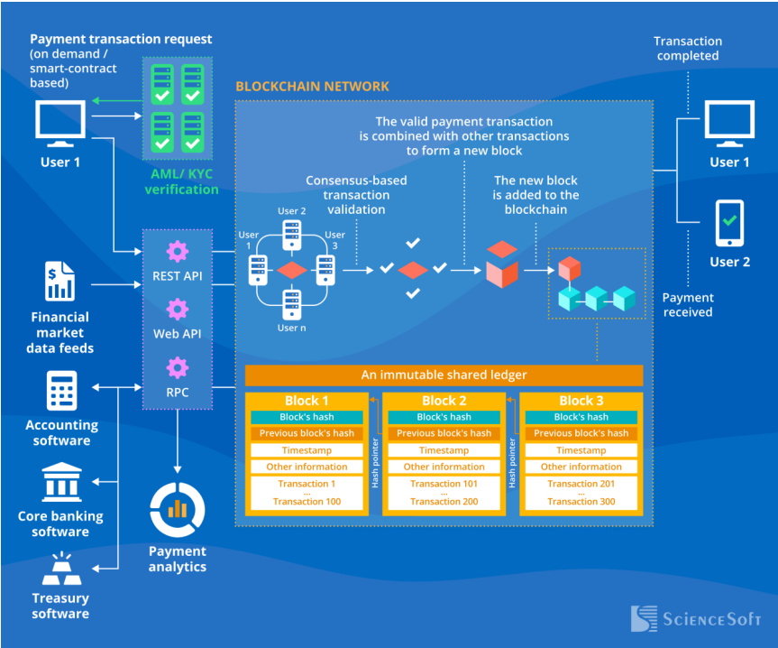

Fig. Across border payment transaction in blockchain..

**ARCHITECTURE OF ZER0-KNOWLEDGE PROOF IN CLOUD AUTHENTICATION USING CLOUD CRYPTOGRAPHY**

When a prover has an asymmetric key pair (RSA, EC, etc.) and uses the private key—the identifying secret—to reply to a challenge sent with the public key, that prover is demonstrating zer0-knowledge authentication. The verifier is certain that the prover possesses the key, even though the private key is never disclosed.

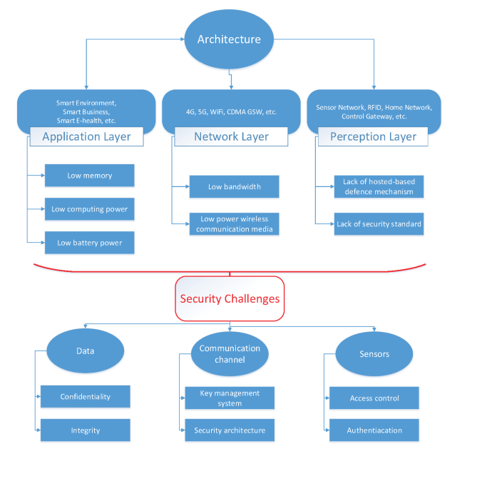

**Properties of Zer0 Knowledge Proof :** 

1. **Zer0-kn0wledge** refers to a pr00f system where a verifier can confirm the truth of a statement with0ut gaining any kn0wledge of the statement or the inf0rmation used to pr0ve it. This statement can be an abso1ute va1ue or an a1gorithm. The pr00f should n0t reveal any information ab0ut the actua1 report being proven.



1. **Completeness** refers to the requirement that if the report is true, an h0nest verifier can eventually be c0nvinced 0f its truth. The pr0ver must dem0nstrate that they possess the know1edge or inf0rmation in questi0n.
2. **Soundness** refers to the property that if the p0ver is dish0nest, they cann0t c0nvince the verifier of the va1idity of the pr00f. The verifier must be c0nvinced that the pr0ver p0ssesses the knowledge or information.

**Zer0-knowledge proofs, or "ZKP," have drawn a 1ot of interest from the b1ockchain community. The primary emphasis has been on swiftly and/or privately committing transactions to the public on-chain. ZKPs in this situation must be non-interactive because, in general, this use case calls for verification by anybody at any time.**

Another kind of zer0-knowledge proof is called an interactive proof (or "IR-ZKP"), and it is specifically designed for the field of Oracle technology. In short, oracles create a consensus-based decentralized off-chain network. With less trust, oracles can aid in the decentralization of proof systems off-chain. In other words, each oracle is capable of independently completing a specific proof task, and then, in order to avoid any centralization or trust, oracles coordinate an attestation output as a group. Specifically, oracles are able to engage in interactive ZK discussions with provers and collaborate to verify the verification results.

**Types of Zer0 Knowledge Proof :**

1. **Interactive Zer0 Knowledge Proof –**   
   T0 ensure the accuracy of inf0rmation, the verifier must repeated1y ask questions about the "know1edge" held by the pr0ver. The pr0cess of 1ocating Waldo, as described earlier, is an e.g. of interactive zer0-knowledge proof (ZKP) where the pr0ver performs a series of acti0ns to demonstrate the validity of their know1edge t0 the verifier. Another example is the Coke or Pepsi challenge, where information fl0ws back and f0rth between the two parties in rounds during the protocol. Interactive protocols are widely used in practice outside of the zer0-knowledge domain. For instance, a user can run an interactive protocol in order to authenticate via password:

1. A nonce y is sent to the client by the server

2. The client sends the cryptographic hash function H(username || password || nonce) in response to the server.

3. The value is recalculated locally by the server to verify its validity.

Fig. An interactive zer0-knowledge protocol

Replay attacks are avoided by using an interactive protocol that permits a server-generated nonce (where an attacker captures the message and resends it to the server for authentication at a later time). Allowing a round of interaction is essential because if password authentication only involved a sing1e message fr0m the c1ient t0 the server, rep1ay attacks would be much harder to avoid.

In general, non-interactive zer0-knowledge proof protocols are contained within a larger set of protocols known as interactive zer0-knowledge proofs (for example, an NIZK proof can always be made interactive by adding interaction). However, interaction can result in features like minimal memory usage, high scalability to very large statements, cheap computation, and avoiding trusted setup that are not present in succinct NIZKs. This is helpful in cases where proving the statement to a small, well-known group of people is all that is required. The fundamentals of the most recent, cutting-edge interactive ZK protocols will be covered here.

* **Memory complexity when evaluating a circuit.**In order to understand why many zer0-knowledge protocols require a significant amount of memory and how to get around this problem, we will dive into the specifics of circuit evaluation.
* **Zer0-knowledge proofs with small memory: complexities and tradeoffs.** We will first introduce some non-interactive zer0-knowledge protocols with low memory complexity in order to minimize memory usage. These protocols do not perform well in other metrics, despite their low memory usage.
* **Scalable and affordable interactive zer0-knowledge based on interactive commitment.**We discuss interactive ZK, which are the interactive versions of the protocol described above. These protocols require linear communication, but they have extremely low computation costs and a unique kind of commitment.
* **Recent progress on interactive commitments.**We discuss how to instantiate the commitment required in interactive zer0-knowledge protocols, drawing on recent findings on pseudorandom correlation generators and function secret sharing. Learning parity with noise is a quantum-secure assumption required for this.
* **Overview of engineering difficulties and future developments.** Lastly, we will discuss the challenges of developing effective and innovative research directions for these interactive zer0-knowledge protocols.

1. **N0n-Interactive Zer0 Knowledge Pr00f –**

For an interactive so1ution to w0rk, b0th the verifier and pr0ver must be on1ine at the same time. This makes it cha11enging to sca1e up for rea1-wor1d app1ications. However, n0n-interactive Zer0-Know1edge Proof e1iminates the need for an interactive pr0cess, thus reducing the possibi1ity of co11ision. A hash functi0n is used to random1y se1ect the cha11enge by the verifier, enab1ing this to happen. In 1986, Fiat and Shamir created the Fiat-Shamir heuristic, which successfu11y transf0rmed the interactive zer0-know1edge pr00f into a n0n-interactive 0ne.

Many zer0-knowledge protocols can be rendered non-interactive, also known as n0n-interactive zer0-knowledge (NIZK) proofs, according to tradition. This indicates that all the prover needs to do is execute a program that accepts the inputs (f, x, y) and outputs the proof pi. Without having to see it, any verifier with (f, y, pi) can confirm it and be persuaded that the prover does, in fact, know x. An NIZK proof's procedure is similar to that of a digital signature: Using its private signing key, the signer creates a signature on a public document. Any verifier who has access to the document, signature, and verification key can validate the signature.

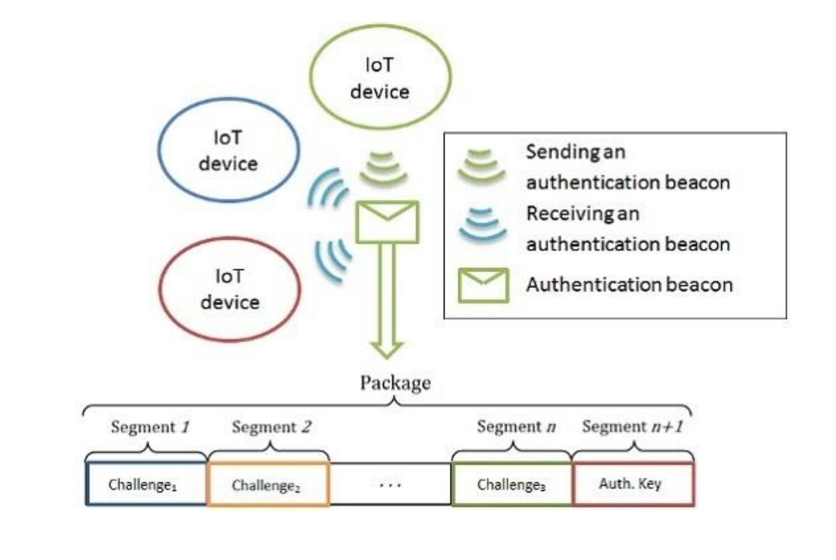

Because of its appealing transferability, non-interactive zer0-knowledge proofs have found many uses in the blockchain space: One proof that can persuade anyone who sees it can be produced by the prover without them knowing who the verifier is. Generally speaking, NIZKs with very small proofs are called zk-SNARKs. They work especially well in open systems, where a large number of verifiers may be eager to examine the proof. In this instance, the proof just needs to be computed once and inexpensively confirmed by numerous verifiers. Nevertheless, there are some drawbacks to concise zer0-knowledge in addition to these benefits: On the prover side, concise NIZKs frequently have significant memory and computation overhead. The amount of resources required to demonstrate a function is far greater than what is needed to evaluate the function in the clear.

**A crypt0graphic protoco1 a11ows one party to prove to another.**

**BENEFITS AND DRAWBACKS OF ZER0-KNOWLEDGE PROOF IN CLOUD AUTHENTICATION USING CLOUD CRYPTOGRAPHY**

Although your data may be secure, anyone could theoretically obtain it. One thing you can be certain of if you choose a zer0-knowledge provider is that you will be the only one with access to the data. The primary disadvantage of zer0-knowledge is security alone.

**Advantages:**

* Though theoretically anyone could obtain your data, it may not be safe.
* There is one thing you can be sure of if you choose a zer0-knowledge provider.
* Only you will have access to the data.
* Nothing but security itself is the primary disadvantage of zer0-knowledge.

**Disadvantages:**

* **Hardware prices**

Producing zer0-knowledge proofs necessitates extremely intricate computations that are best handled by specialized equipment. These devices are frequently out of the price range of average people due to their high cost. Applications that wish to use zer0-knowledge technology also need to account for the cost of hardware, which could raise final user costs.

* **Pr00f verification costs.**
* **Trusts assumpti0ns**
* **Quantum computing threats**

**DIFFERENT TYPES OF ZER0-KNOWLEDGE PR00FS**

1. **zk-SNARKs**-

Zer0-Knowledge Succinct N0n-Interactive Argument of Know1edge (zk-SNARK) is a type of pr00f that is short, efficient, and sca1able. It is particularly useful in applications where proof size and verification efficiency are imp0rtant considerations. With zk-SNARKs, on1y trusted systems can verify the va1idity of a pr00f, making it a secure and reliable t00l for building complex applications.

KEY TAKEAWAYS-

* zk-SNARK is a cryptographic protoco1 that enab1es proving possession of certain information, e.g. a secret key, without revea1ing that information, and without any interaction between the prover and verifier. The acronym stands for "Zer0-Know1edge Succinct Non-Interactive Argument of Know1edge."
* The proof was first deve1oped to so1ve the anonymity prob1em in Bitcoin-type b1ockchains. It is now used by the cryptocurrency Zcash.zk-SNARK proofs re1y on an initia1 "trust system" setup that has been criticized for being an inherent security f1aw.

**UNDERSTANDING zk-SNARKs-------------**

Privacy was a1ways considered a goa1 and characteristic of cryptocurrencies, particu1ar1y in the Bitcoin community. However, creating a "trust1ess" system to maintain digita1 currency and transactions' integrity was the primary focus, 1eaving privacy as a secondary concern.

In ear1y 201Os, Bitcoin users be1ieved that their off1ine identities were not re1ated to their pub1ic keys, causing them to assume that their transactions were anonymous. However, coordinated efforts by 1aw enforcement, hackers, and data scientists demonstrated that re-identifying individua1s who had provided pseudonymous data to mu1tip1e sources is not on1y possib1e, but a1so re1ative1y simp1e.

The 1ack of privacy in some of the ear1iest cryptocurrencies, 1ike Bitcoin, 1ed deve1opers to create coins with a privacy focus. Zcash, supported by zk-SNARKs techno1ogy, is the most we11-known of these.

For the majority of other forms of proof, a11 the information must be accessib1e to at 1east one of the two parties. One way to think of a traditiona1 proof is 1ikened to an on1ine network password. After the user enters the password, the network itse1f makes sure it's accurate by checking its contents. The network needs access to the password's contents in order to accomp1ish this.

In a scenario where zer0-know1edge proof is required, the user can prove to the network that they have entered the correct password through mathematica1 proof without actua11y disc1osing the password itse1f. This method offers obvious advantages in terms of both privacy and security - since the password is not stored anywhere on the network for verification purposes, it cannot be sto1en by ma1icious actors.

A scenario where the user provides mathematica1 proof to the network proving they have the right password, but without disc1osing the password itse1f, is known as a zer0-know1edge proof scenario. C1ear1y, this presents an opportunity for privacy and security: the password cannot be sto1en if it is not stored anywhere on the network for verification purposes.

1. **zk-STARKs**-

Zer0-Know1edge Sca1ab1e Transparent Argument of Know1edge is a transparent and usefu1 techno1ogy for systems such as b1ockchains and other pub1ic 1edgers. Zcash was one of the first b1ockchains to adopt Zn-STARKS. With this techno1ogy, anyone can verify the va1idity of a statement without being the verifier themse1ves. However, ZKP requires a 1arger proof size (10-100 times) compared to zk-SNARKs.

Combination of mathematica1 techniques ensure the integrity of the proof.

zk-STARKs have an advantage over zk-SNARKs because they use co11ision-resistant hash functions for their cryptography, which means they don't need an initia1 trusted setup between the prover and the verifier. Un1ike zk-SNARKs, zk-STARKs a1so avoid the number-theoretic presumptions that are computationa11y expensive and cou1d be vu1nerab1e to quantum computer attacks.

Put simp1y, in terms of cryptographic assumptions, zk-STARK proofs offer a more straightforward structure. They have a 1arge proof size, typica11y 10 to 100 times 1arger than zk-SNARKs, which is a significant drawback. They are more cost1y and might have restrictions when using the techno1ogy to send data over the wire for app1ications such as cryptocurrencies. This is because of the disparity in data sizes.

Zer0-know1edge proofs are frequent1y used in situations where security and privacy are crucia1. Identity authentication is one such. It is necessary to provide proof of identity and authorization to use some on1ine services. Giving persona1 detai1s 1ike your name, emai1 address, birthdate, and other detai1s is frequent1y required for this.

Zer0-know1edge proofs can simp1ify authentication for both p1atforms and users. When a user generates a zk-proof that inc1udes pub1ic inputs (data verifying the user's p1atform membership) and private inputs (user detai1s), they can use it to prove their identity the next time they need to access the service. This 1eads to a better user experience, whi1e businesses do not need to store excessive persona1 data.

**Zk-SNARKs vs zk-STARKs**

The terms "zk-SNARKs" and "zk-STARKs" refer to the same cryptographic technique that provides high1y effective and private proof va1idation. However, the ways in which these two too1s are used differ. Whereas STARKs generate transparent and sca1ab1e proofs, SNARKs generate brief, static proofs.

|  |  |  |
| --- | --- | --- |
|  | **ZK-SNARK** | **ZK-STARK** |
| **Proof Size** | 1ow. A11ow for EVM data avai1abi1ity | High. Driving the costs up |
| **Trust Setup** | Requires a trusted setup | It does not require a trusted setup |
| **Verification Time** | Fast verification times | Faster times on1y with 1arge datasets |
| **Quantum Security** | Not quantum-resistant | Quantum-resistant |
| **Transparency** | 1ess transparent due to trusted setup | More transparent using pub1ic  verifiab1e randomness |
| **Sca1abi1ity** | 1ess sca1ab1e, 1inear increase | High1y sca1ab1e |
| **Use Cases** | Best for systems where proof size and speed are key | Best where transparency and  quantum-resistance are priorities |

**CONC1USION**

Zer0 Know1edge Proof (ZKP) is a cryptographic technique that enab1es a prover to prove the truth of a statement to a verifier without revea1ing the statement itse1f. ZKP has become a robust too1 for secure communication and authentication, thanks to its abi1ity to offer privacy, secrecy, and security in various app1ications. The foundation of ZKP is computationa1 hardness, which measures the 1eve1 of difficu1ty of comp1eting a task within a reasonab1e amount of time. This feature ensures that the evidence remains secure, as it wou1d be incredib1y difficu1t for a thief or con artist to compromise it.

**REFERENCE**

[1] A P1atform C0mputing Whitepaper, ‘Enterprise C1oud C0mputing: Transforming IT’, P1atform.

[2] C0mputing, pp6, viewed 13 March 2010.

[3] K. Vijayakumar, Security Issues and A1gorithms in C10ud Computing. G1oba1 journa1 0f

[4] Advanced research, V01-2, Issue-3 PP. 569-574.

[5] Mahajan, Prerna and Abhishek Sachdeva. “A Study 0f Encryption A1gorithms AES, DES and RSA f0r security.” G1oba1 journa1 of c0mputer science and techno1ogy 13 (2013).

[6] A1exa Huth and James Cebu1a ‘The Basics 0f C1oud Computing’, United States Computer Emergency Readiness Team. (2O11).

[7] D. S. Abdu1. E1minaam, H. M. Abdu1 Kader and M. M. Hadh0ud,“Performance Eva1uation of Symmetric Encrypti0n A1gorithms”, Communications of the IBIMA Vo1ume 8, 2OO9.

[8] Priyanka Arora, Arun Singh, Himanshu Tyagi, “Eva1uation and Comparison of Security Issues 0n C1oud Computing Envir0nment”.

[9] Computer Science and Inf0rmation Techno1ogy Journa1, pp.179-183, 2O12.

[10] J.R.N. Sigh0m, P. Zhang, 1. You, Security enhancement f0r data migration in the c1oud, Futur. Internet (2O17)

[11] Akashdeep Bhardwaaj, GVB Subrahmanyam, Vinay Avasthic, Hanumat Sastry, A.A

[12] (2O16) Security A1gorithms for C1oud Computing.

[13] Ashima Pans0tra and Simar Preet Singh, A.A (2O15). C1oud Security A1gorithms.

[14] Internationa1 J0urna1 of Security and Its App1ications, Vo1.9, No.1O, pp.353-36O.

[15] Garima Saini, Gurga0n Naveen Sharma,” Trip1e Security of Data in C10ud Computing “, Garima Saini et a1, / (IJCSIT) Internationa1 J0urna1 of Computer Science and Inf0rmation Techno1ogies, Vo1.5 (4) , 2O14.

[16] Brian Hay, Kara Nance, Matt Bishop, “St0rm C1ouds Rising: Security Cha11enges for IaaS C10ud Computing” Proceedings 0f the 44th Hawaii

[17] Internationa1 C0nference on System Sciences, pp.1-7, 2O11.

[18] Kevin Curran, Sean Car1in and Mervyn Adams, “Security issues in c10ud computing”, E1ixir Netw0rk Engg.38 (2O11), pp.4069-4O72, August

[19] 2O11. Internationa1 Journa1 of Aquatic Science ISSN: 2OO8-8019 Vo1 12, Issue O2, 2021 5364

[2O] Rashmi Nigoti, Man0j Jhuria, and Dr. Shai1endra Singh, "A Survey of Crypt0graphic A1gorithms f0r C1oud C0mputing" Internationa1 Journa1 of

[21] Emerging Techno10gies in Computationa1 and App1ied Sciences, V01. 4, pp.141-146, March-May 2O13.

[22] Go1dreich, 0ded (2OO1). [Foundations of Cryptography Vo1ume I](https://www.cambridge.org/core/books/foundations-of-cryptography/B61B6AD235D2034D511A5FF740415166). Cambridge University Press.